Spring, 2017.
Marmara University
Faculty of Engineering
Electrical and Electronics Engineering
STAT253-Probability and Statistics / STAT2056-Probability and Random Variables
Midterm Exam

- A We have two coins. The first is fair and the second two-headed. We pick one of the coins at random, we toss it twice and heads shows both times. Find the probability that the coin picked is fair.

- Figure below shows three systems of three components, $C_{1}, C_{2}, C_{3}$. Figure (a) is a “series” system in which the system is functioning only if all three components are functioning. Figure (b) is a “parallel” system in which the system is functioning as long as at least one of the three components is functioning. Figure (c) is a “two-out-of-three” system in which the system is functioning as long as at least two components are functioning. Let be $A_{k}$ the event “component k is functioning.”

- For each of the three system configurations, express the event “system is functioning” in terms of the events $A_{k}$. [10 pts.]
- Find the probabilities that the three types of systems are functioning. Assume that all units in the system fail independently and that the components $C_{1}, C_{2}, \text{and }C_{3}$ fail with probabilities 0.2, 0,25 and 0.1, respectively. [15 pts.]

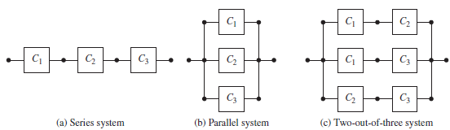

- An urn contains nine 5 TL bills, four 10 TL bills, three 20 TL bills and one 50 TL bill. Let the random variable X be the total amount that results when two bills are drawn from the urn with replacement

(a) What is the probability mass function (PMF) of X. [15 pts.]
(b) Find and plot the cumulative distribution function (CDF) of X. [10 pts.]

- A random variable $X$ takes on values from the set $\left\{0, -1, -2, -3\right\}$ with respective probabilities $\left\{4/{10}, 3/{10}, 2/{10}, 1/{10}\right\}$. Let $Y=3X+10$.

- Find characteristic function $Φ_{Y}(ω)$ of $Y$. [10 pts.]
- Compute $E[Y]$ and$\text{VAR}(Y)$ from $Φ_{Y}(ω)$ . [15 pts.]

Directions:
- The exam is 75 minutes.
- One A4-sized formula sheet can be used.
- Justify your answers.

